***Branor***

“*The people praise him. Bards sing of his deeds. His peers are in awe of his strength. He is Branor the Paladin,the pride of Kingsdor. Branor's story is one oft-heard. A wide-eyed child dreamed of greatness and trained tirelessly ever since he could hold a sword. But Branor wasn't content with being just another knight. He wanted to be a paladin; a protector of peace. Branor earned his stripes during a skirmish with the Moonseekers. The battlefield was attacked by an Ifrit, which quickly wiped out most of the skirmishers. Amidst the chaos, Branor gathered and led the survivors from both side to safety. This noble act earned him a place amongst the Paladins."*

### *Active Skills*

#### Judgement (Army Skill)

*Hero unleashes skill that deals DMG to target equal to****105/110/120/140/200%****of Brigade ATK.*

#### Vicious Cuts (Combat Skill)

*Dedicate all strength to cutting left and right, followed up by three double-handed heavy cuts. Each cut deals 21% physical DMG and increases Hero's Physical and Magic DEF by****20/30/35/40/50%****.*

### *Passive Skills*

#### Bastille (Hero: permanent)

*Hero DEF up by****1.5/3/6/12/30%****.*

#### Food Production (Admin: permanent)

*Food Production up by****25/50/75/125/250%****.*

#### Field Marshal (Admin: permanent)

*Increase Training Facility capacity by****0.5/1/1.5/2.5/5%****.*

#### Armored Infantry (Commander: conditional)

*Increases Infantry DEF by****2.5/5/10/20/50%****; effect activated when the player initiates an attack or defense.*

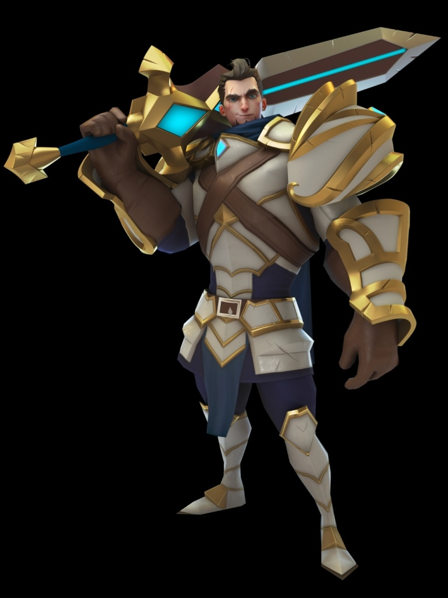

***Saoirse***

*"Saoirse listened closely as the dragon spoke. The deep growls shook the leaves and caused the Earth to tremble, but Saoirse felt understanding stir within her. Their conversation however, was cut short by the scream of a patrolling ranger. When the incident was reported, the elven elders told that only someone with exceptional magical talents could understand the language of the dragons, an ancient tongue that can channel tremendous amounts of magic. Saoirse was encouraged to nurture her talent. Though she heard only a little of the language, what she knew was enough to make her one of the best healers in the world."*

### *Active Skills*

#### Holy Punishment (Army Skill)

*Deal DMG to target equal to****105/110/120/140/200%****of Brigade ATK.*

#### Holy Heal (Combat Skill)

*Sing an ancient chant to manifest a magic circle and heal friendly troops within range equal to****40/46/52/60/70%****of magic ATK.*

### *Passive Skills*

#### Bastille (Hero: permanent)

*Hero DEF up by****1.5/3/6/12/30%****.*

#### Fortitude (Hero: permanent)

*Hero HP up by****1.5/3/6/12/30%****.*

#### Harvesting Expert (Admin: permanent)

*Harvesting speed of all resources up by****2.5/5/7.5/12.5/25%****.*

#### Manage Resources (Admin: permanent)

*Resource production up by****5/10/15/25/50%****.*

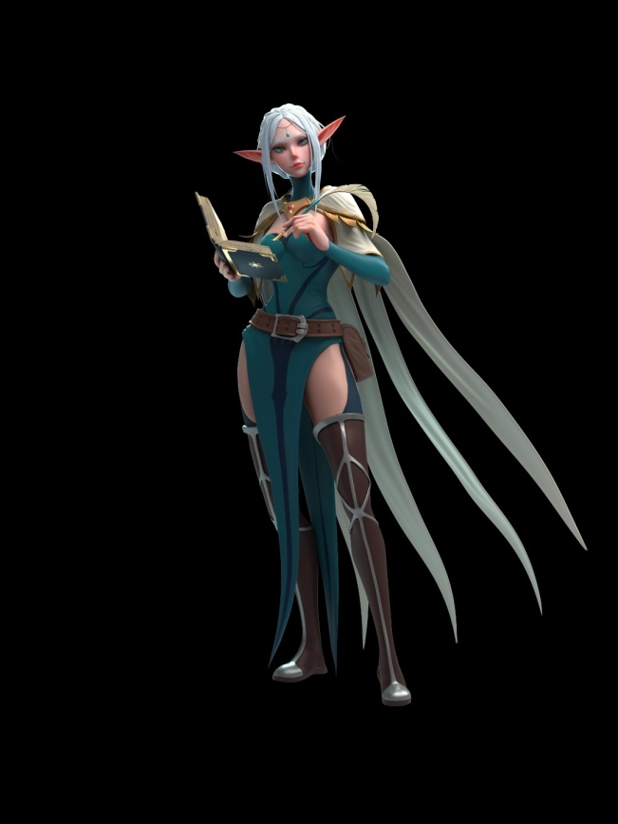

## *Valenia*

*“Once upon a time, the elves controlled a vast empire that spanned the continent. The elves lived in luxury, drawing all their energy from the Eternal Crystal, a boundless well of power. But an unfortunate accident shattered the Eternal Crystal, resulting in a bitter civil war. The elves splintered into two tribes, the Sunsinger warriors and the Moonseeker mages. The Sunsingers trained Blademasters to counter the powerful mages. Elves like Valenia, who were very sensitive to magic, were recruited from young and schooled in anti-magic arts. After a lifetime of indoctrination, Valenia firmly believed that all mages were evil, and had to be put down like the dangerous animals they were.”*

### Active Skills

#### Flash Slash (Army Skill)

*Deal DMG to target equal to****105/110/120/140/200%****of Brigade ATK.*

#### Shadow Slash (Combat Skill)

*Rush towards the target and unleash an X slash that deals 53% physical DMG, and then return to original spot. If target’s HP is below 40%, Hero deals****50/60/70/90/120%****more skill DMG.*

### Passive Skills

#### Barrage (Hero: permanent)

*Hero ATK up by****1/2/4/8/20%****.*

#### Wood Production (Admin: permanent)

*Wood Production up by****15/30/45/75/150%****.*

#### Expert Builder (Admin: permanent)

*Construction SPD up by****2/4/6/10%.***

#### Field Marshal (Hero: conditional)

*Increase Training Facility capacity by****0.5/1/1.5/2.5/5%.***

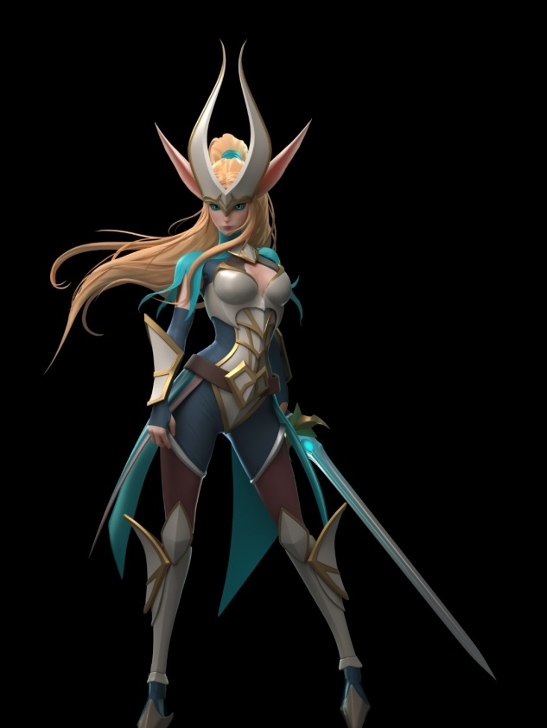

## *Reginald*

"*Most would agree that Reginald led a "charmed life". Born into the royal family of Kingsdor, Reginald enjoyed a peaceful childhood a lavish castle. He read about wars that were fought before he was born, and studied under the best tutors in the country. Reginald's life was turned upside down when the king died. His family not only refused to acknowledge him as heir to the throne, but also accused him of killing his own father. When the scandalous news spread to the public, it sparked anger and unrest. With Kingsdor entering into an era of political strife and unrest, Reginald must show that he is the rightful heir of Kingsdor!"*

### *Active Skills*

#### Lancelot (Army Skill)

*Deal DMG to target equal to****105/110/120/140/200%****of Brigade ATK.*

#### Kingsdor Strikes (Combat Skill)

*Reginald teams up with the unicorn to unleash a lance attack, dealing****50/100/150/200/300%****more skill damage, and 4 lightning-quick strikes. Each strike deals 20% physical DMG.*

### *Passive Skills*

#### Fortitude (Hero: permanent)

*Hero HP up by****1.5/3/6/12/30%****.*

#### Building Speed (Admin: permanent)

*Increase Construction Speed by****3/6/9/15/30%****.*

#### Bastille (Hero: permanent)

*Hero DEF up by****1.5/3/6/12/30%.***

#### Deadly Cavalry (Hero: conditional)

*Increase Cavalry ATK by****3/6/12/24/60%****; Effect is activated when player initiates an attack or defense*

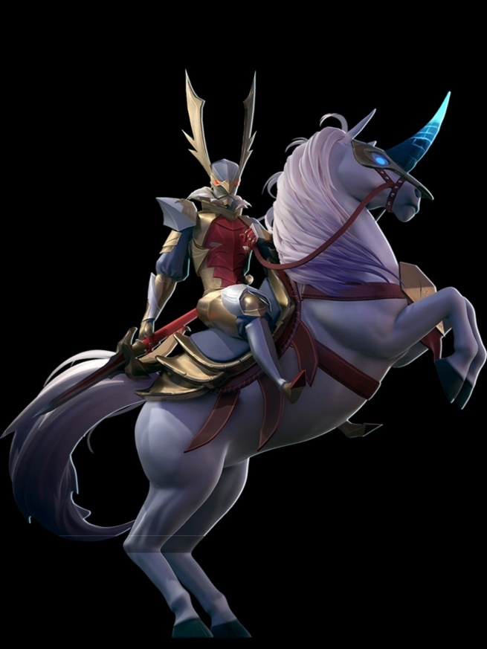

## *Gargantor*

”Gargantor, the king of Anthropos, has never known a day's peace. He was born in a kingdom that suffered daily from war, raids, and rebellion. Faced with danger on all sides, Gargantor quickly learned the value of loyalty. Gargantor chose to wield a shield, to symbolize his determination to defend Anthropos. In the hands of Gargantor, the shield was a deadly weapon. His unique combat style and iron will allowed him to quell the rebellion, expel invaders, and secure the throne. After witnessing him in action, many took to calling him "Metal King".”

### Active Skills

#### Iron Bash (Army Skill)

*Deal DMG to target equal to****105/110/120/140/200%****of Brigade ATK.*

#### Shield Smash (Combat Skill)

*Split the giant shield in half, and swing them to the right and left, before smashing them into the ground to generate a massive force wave. Each hit deals 22% physical DMG, and increases Hero’s physical DEF by****35/40/45/50/70%.***

### Passive Skills

#### Bastille (Hero: permanent)

*Hero DEF up by****1.5/3/6/12/30%***

#### Expert Builder (Admin: permanent)

*Construction SPD up by****2/4/6/10/20%***

#### Increase Infantry Brigades (Admin: permanent)

*Increase Infantry Brigades deployed by****1/2/3/4/6***

#### Armoured Infantry (Commander: conditional)

*Increase Infantry DEF by****2.5/5/10/20/50%****; effect activated when player initiates an attack or defense*

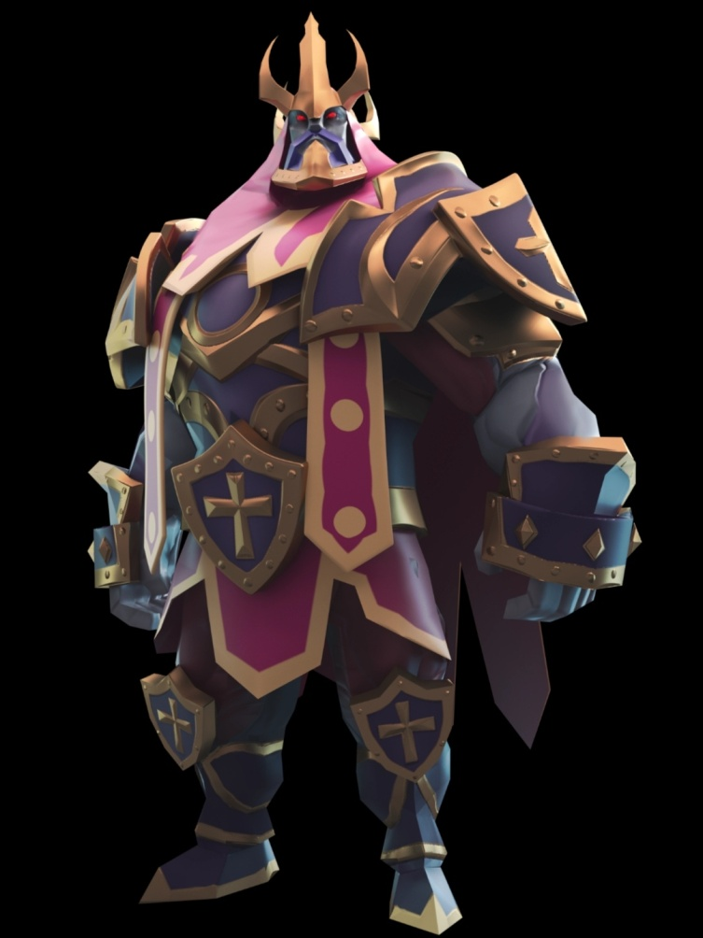

## *Cynthea*

*”After the war with the demons, the first to learn magic were the elves, and they were the earliest spellcasters.*

*These spellcasters were guided by the Ancient Dragons, and they used the magic of nature to heal the war torn land.*

*To thank the spellcasters for their work, the elves built a resting place for them where they could go to sleep and recover their magical powers. Cynthea was one of those spellcasters.*

*Time went by, and when the elves discovered the Eternal Crystal, they became obsessed with experimentation and forgot about the resting place.*

*When the crystal exploded, the blast sent many of the spellcasters into eternal sleep, but luckily, Cynthea only suffered some minor damage, and several centuries later, she awakened...*

*Looking around, she realised that she had slept for a very long time indeed, and she ventured out of the woods to see the land that she saved ages ago...”*

### Active Skills

#### Raging Thorns (Army Skill)

* *Deal DMG to target equal to****105/110/120/140/200%****of Brigade ATK.*

#### Earthly Trap (Combat Skill)

* *A hardy trap weaved out of enchanted vines. Deals 26% magic DMG to all targets within range, decrasing targets' physical DEF and magic DEF by****5/10/15/20/30%****. Effect last for 3 seconds.*

### Passive Skills

#### Barrage (Hero: permanent)

* *Hero ATK up by****3/5/7/12/20%***

#### Blessed Ranged (Commander: conditional)

* *Increase Ranged HP by****2.5/5/10/20/50%****; effect activated when player initiates an attack or defense*

#### Deadly Ranged(Commander: conditional)

* *Increase Cavalry ATK by****1.5/3/6/12/30%****; effect activated when player initiates an attack or defense*

#### Deadly Army (Commander: conditional)

* *Increase Army ATK by****1/2/4/8/20%****; effect activated when player initiates an attack or defense*

**

## *Aoi*

*"As an outsider, Aoi's actions are under constant scrutiny. However, her respectful behavior and good manners soon had locals observing her out of curiosity instead.* It is rumored that, after defending a village from a group of bandits, she refused the reward offered by the villagers, and only took a few foodstuffs. While her intentions remain a mystery, many have speculated that she is looking for a worthy leader to serve. "

### *Active Skills*

#### Shiraha Slice (Army Skill)

*Deal DMG to target equal to****105/110/120/140/200%****of Brigade ATK.*

#### Iaido Dance (Combat Skill)

*causes 32% of physical DMG, with a****35/40/45/50/60%****chance of stunning targets for 2.5 seconds*

### *Passive Skills*

#### Barrage (Hero: permanent)

*Hero ATK up by****3/5/7/12/20%****.*

#### Drill Sergeant (Admin: permanent)

*Barracks training SPD up by****2/4/6/10/20%****.*

#### Armored Army (Commander: conditional)

*Increase army DEF by****1.25/2.5/5/10/25%****. Effect activated when player initiates an attack or defense.*

#### Deadly Army (Commander: conditional)

*Increase army ATK by****1/2/4/8/20%****. Effect activated when player initiates an attack or defense.*

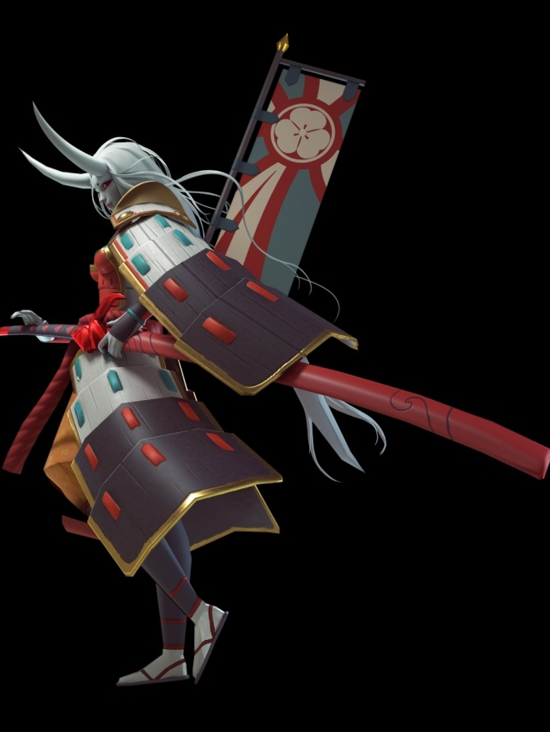

## *Skullrock*

*”*Known as "The Beastkin that slew death", Skullrock is a legendary figure in Vollandia, rumored to be invincible.Skullrock had always claimed that fighting was the one thing that made him feel alive. It was said that he died of exhaustion fighting over a thousand elves by himself, his body no longer able to keep up with his desire for blood.By some dark magic, Skullrock was resurrected. As he qot up from the blood-soaked ground, only thoughts of battle filled his mind.Every once in a while, images of life pierce through the red mist in his mind. Memories that were once dismissed as mundane and insipid now cause great confusion. Has life alwavs been more than battle?”

### Active Skills

#### Bladestorm (Army Skill)

* *Deal DMG to target equal to****105/110/120/140/200%****of Brigade ATK.*

#### Draconic Whirl (Combat Skill)

* *Skill DMG increase by****10/12/14/16/20%.****for every 10% HP lost*

### Passive Skills

#### Barrage (Hero: permanent)

* *Hero ATK up by****3/5/7/12/20%***

#### Hero CRIT rate (Hero: permanent)

* *Hero CRIT rate up by****2.5/5/10/15/25%***

#### Drill Sergeant(Admin: permanent)

* *Barracks training SPD up by****2/4/6/10/20%***

#### Deadly Army (Commander: conditional)

* *Increase Army ATK by****1/2/4/8/20****; effect activated when player initiates an attack or defense*

